The HAL Company

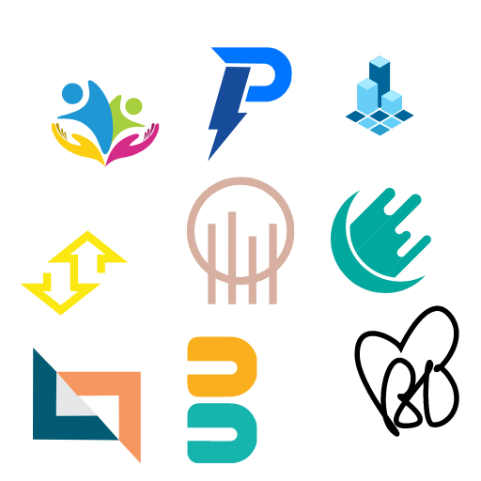

**The Indigo Project**

Date: 19th January 2024

To: Armand Harmon (C.E.O)

CC: Michele Lenox (C.P.O)

From: Christian Spalluto, William Salhany, Randolph Svitzer (Project Managers)

At this point we have four resources overallocated. Design Engineer, Industrial Engineer, Marketing Specialist and Purchasing Agent. The activities affected will be Research and development, Product testing and Product execution. Leveling all over allocations would result in changing the finish date from 7/30/2026 to 8/5/2026. Leveling over allocations within slack would cause a finish date issue if there were a time constraint. We wouldn’t be able to resolve the Industrial Engineer to finish with a time constraint of 7/30/2026.